**Zootecnia**

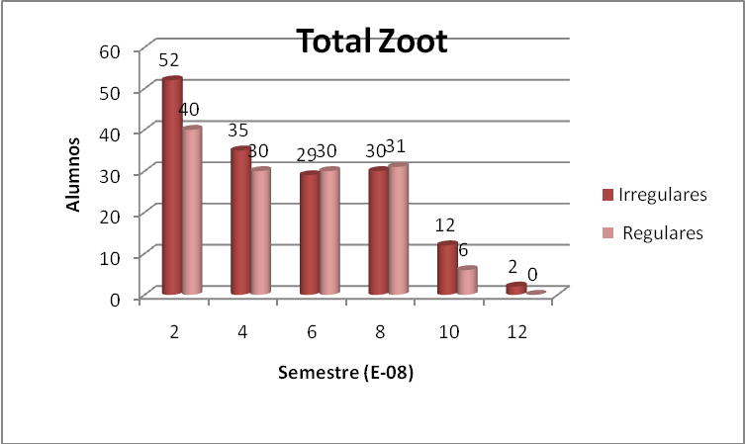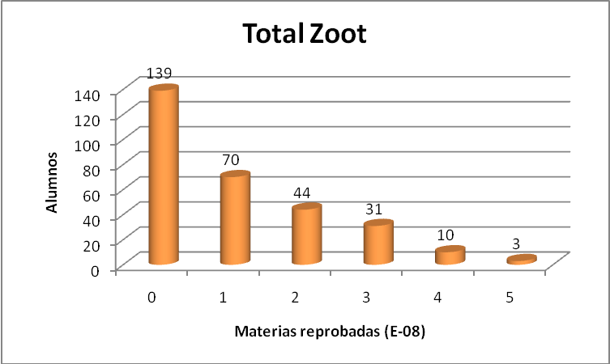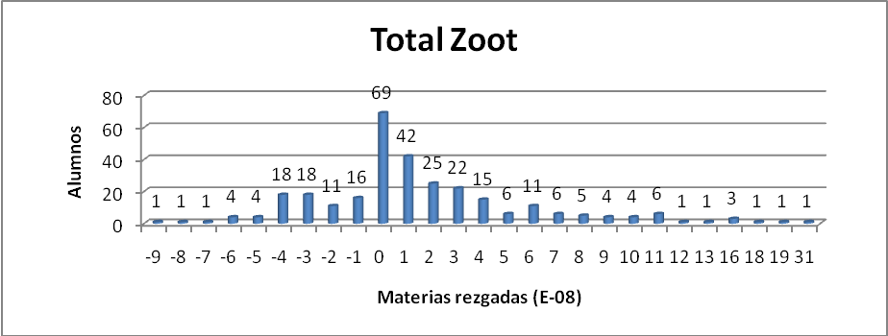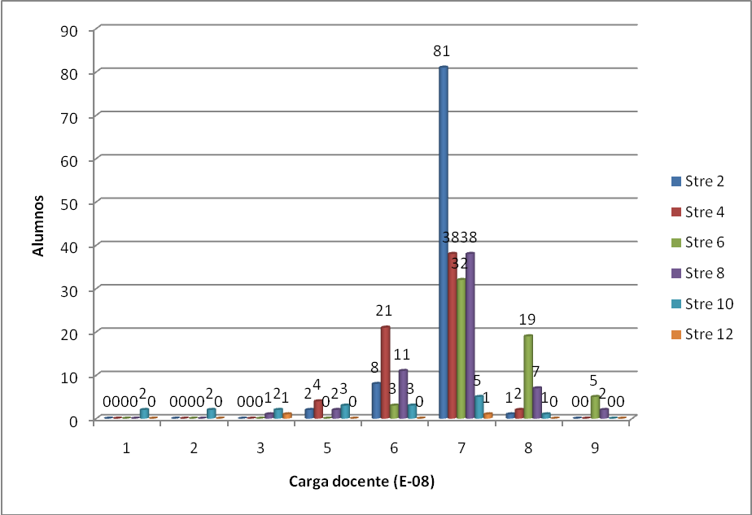

52 % de alumnos con rezago



|  |  |  |  |  |  |  |
| --- | --- | --- | --- | --- | --- | --- |
| Reprob.  Rezag. | **Regulares** | | **Irregulares** | | Suma | |
| Alum’s | ***%*** | Alum’s | ***%*** | Alum’s | ***%*** |
| **Ninguna** | 114 | ***38*** | 29 | ***10*** | 143 | ***48*** |
| **Una o más** | 23 | ***8*** | 131 | ***44*** | 154 | ***52*** |
| Suma | 137 | ***46*** | 160 | ***54*** | 297 | ***100*** |

**Segundo semestre**

